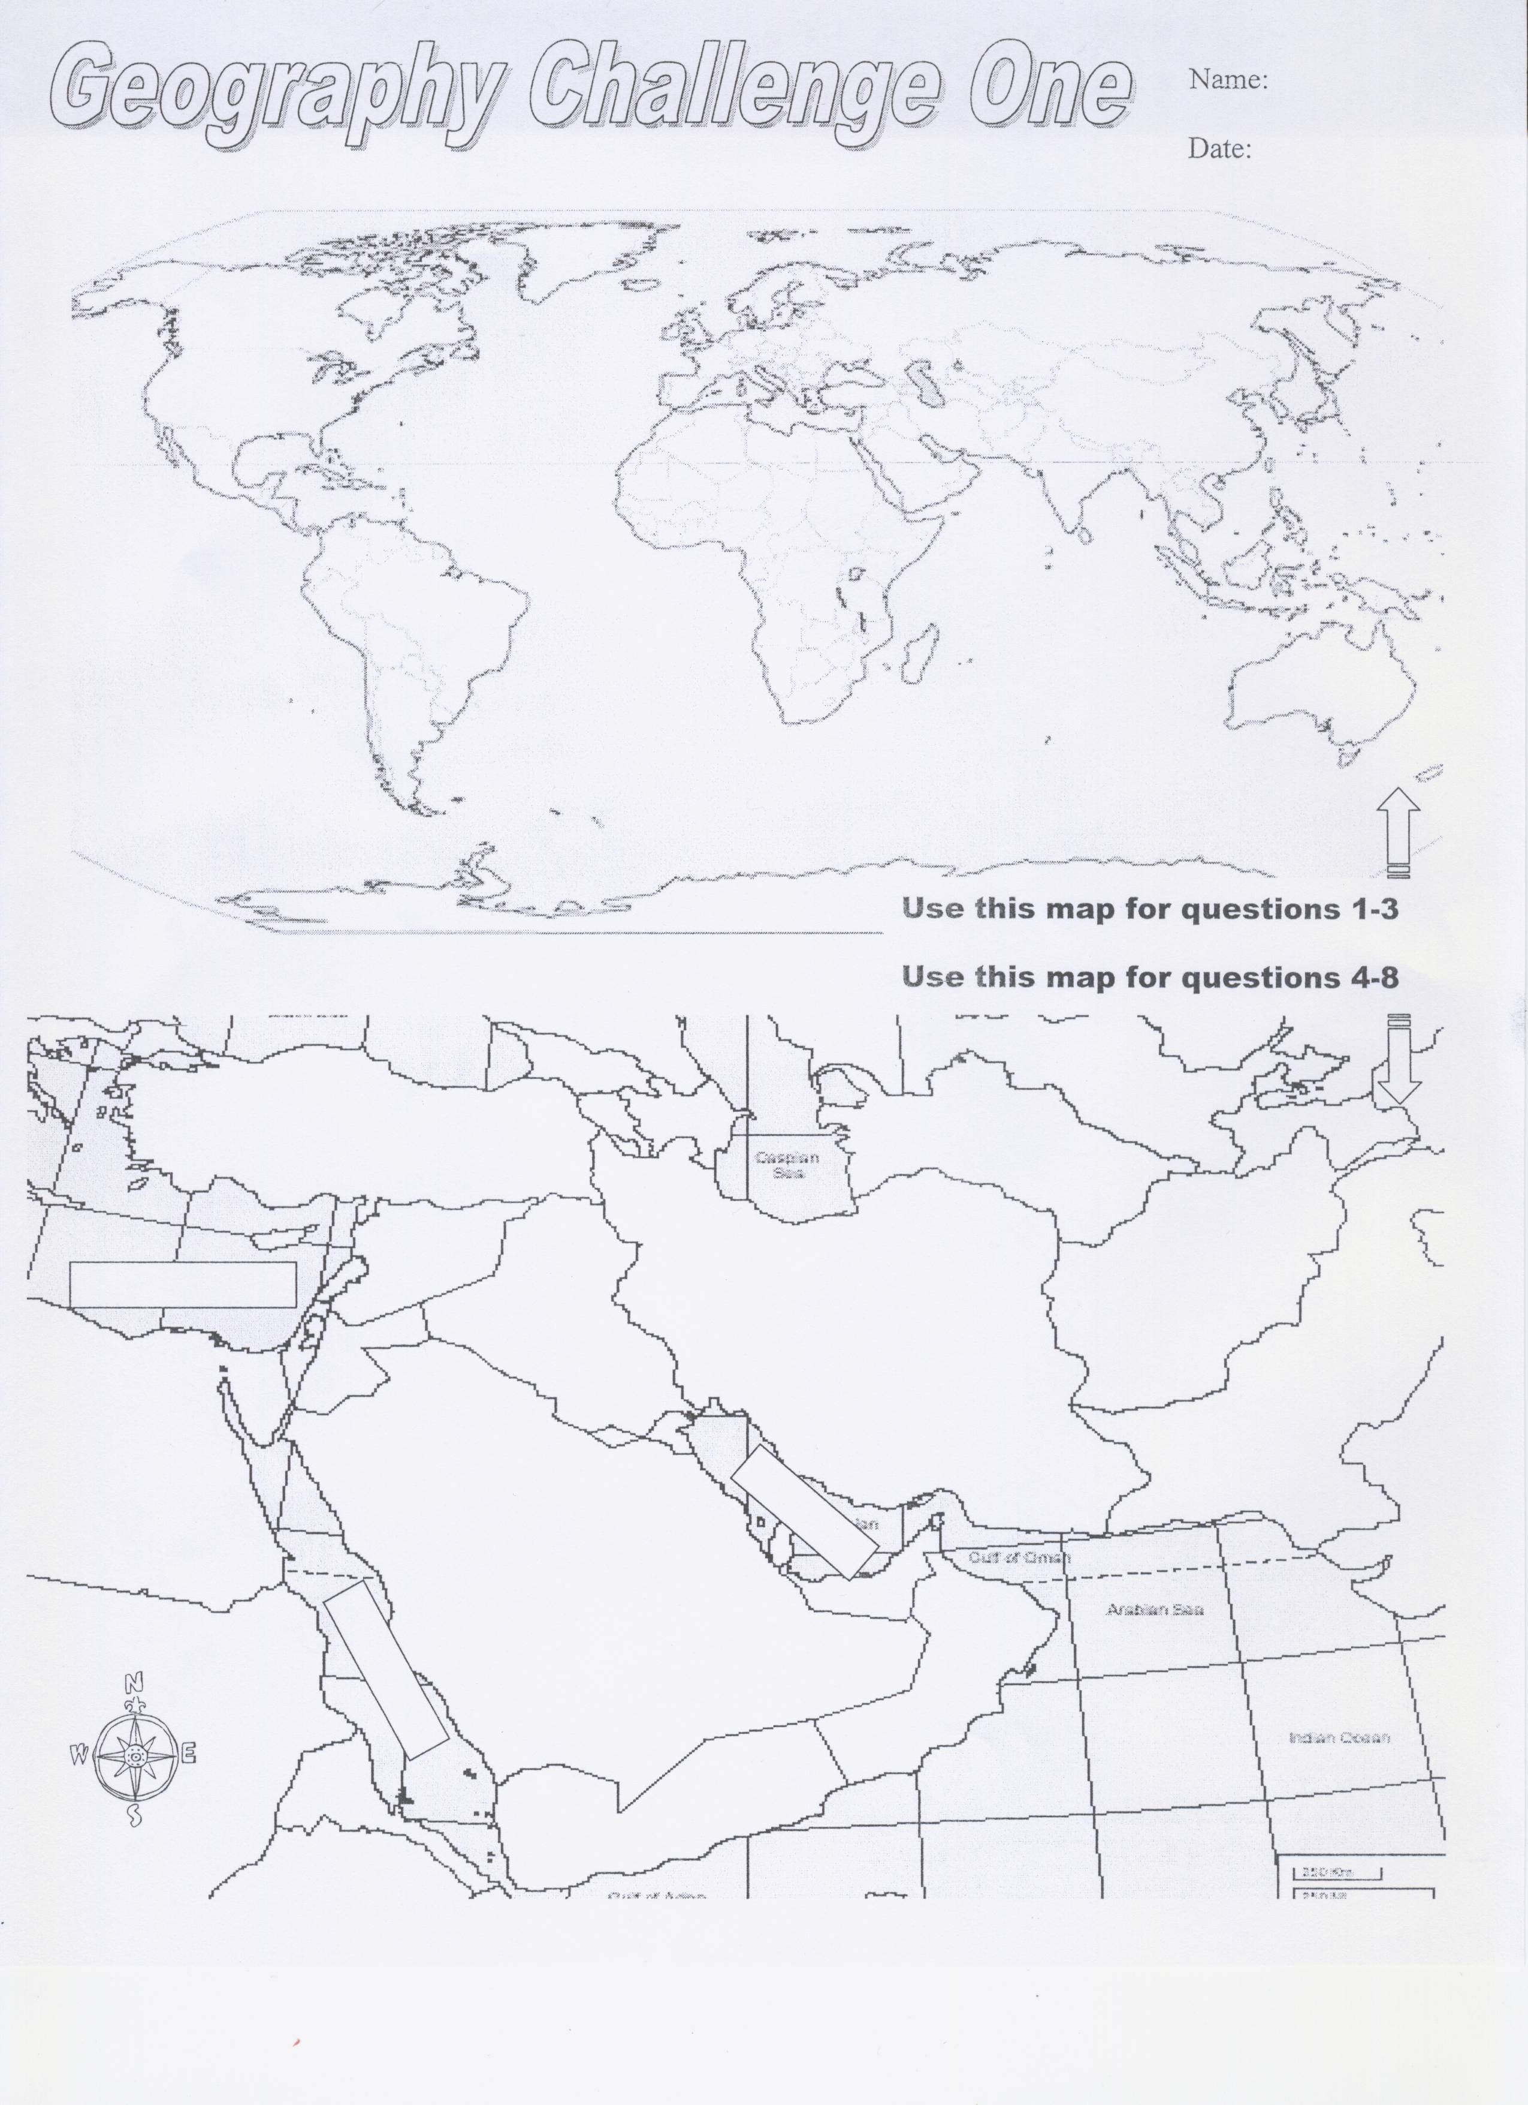
North America
South America

Europe
Asia
Australia
Antarctica
Indian Ocean
Atlantic Ocean
Pacific Ocean
Pacific Ocean
Arctic Ocean
Southern Ocean

Geo Challenge Study Guide (Remove the boxes to reveal the answers)
Africa

